**To install postman: -**

<https://www.getpostman.com/downloads/>

1. CLICK ON DOOWNLOAD THE APP

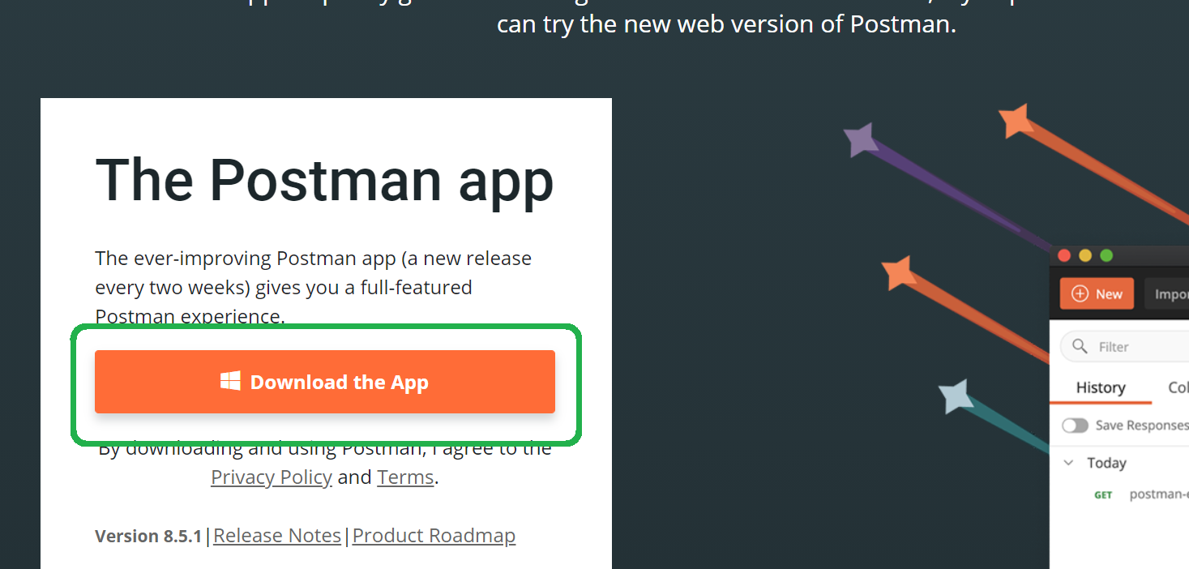

1. CLICK ON Windows 32-bit or Windows 64-bit based on your OS

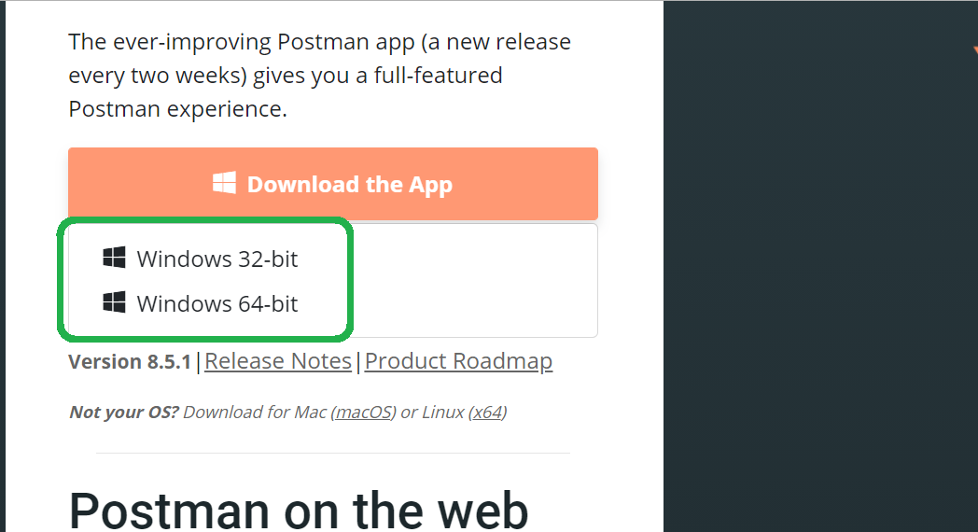

1. After downloading below file double click on it

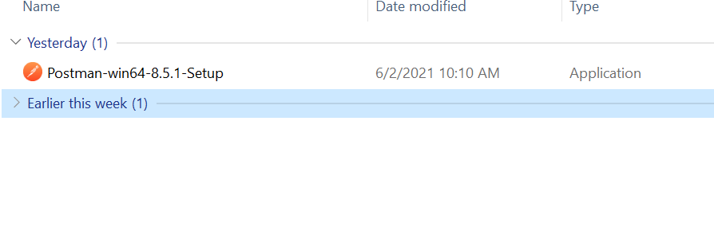

1. AFTER INSTLLING IT WILL ASK CREATE ACCOUNT WINDOW, CLOSE THIS WINDOW AND REOPEN POSTMAN

